| **Project – External Document** |  |
| --- | --- |
| COMP6681001  Web Programming |
| Odd Semester Year 2021/2022 |

* **Project Title**

Book Store

* **Introduction**

In this project, we are making a Book Store website using Laravel framework

* **Report / Documentation**

1. Login

In this page the registered user can login with their account

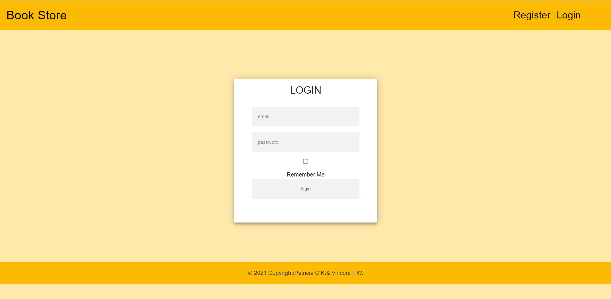

1. Register

If the user/visitor does not have an account, he can register it first

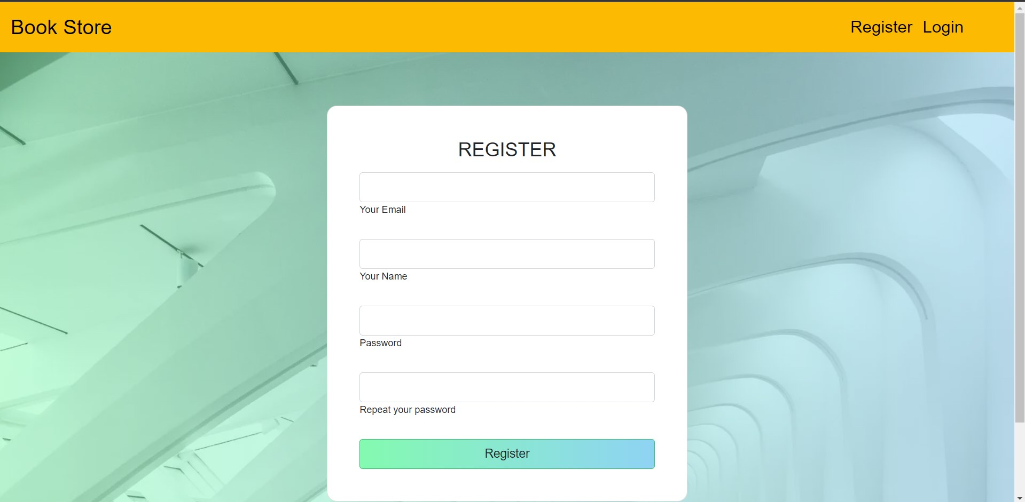

1. Home

when first time open the web you will be see the guest home page, each role have different navbar, for guest there will be register and login, for admin there will be manage (user, book genre, profile changepassword) for member there will be view cart, view transaction history profile and change password, in home page user can search by using title of the book and can see the detail of the book.

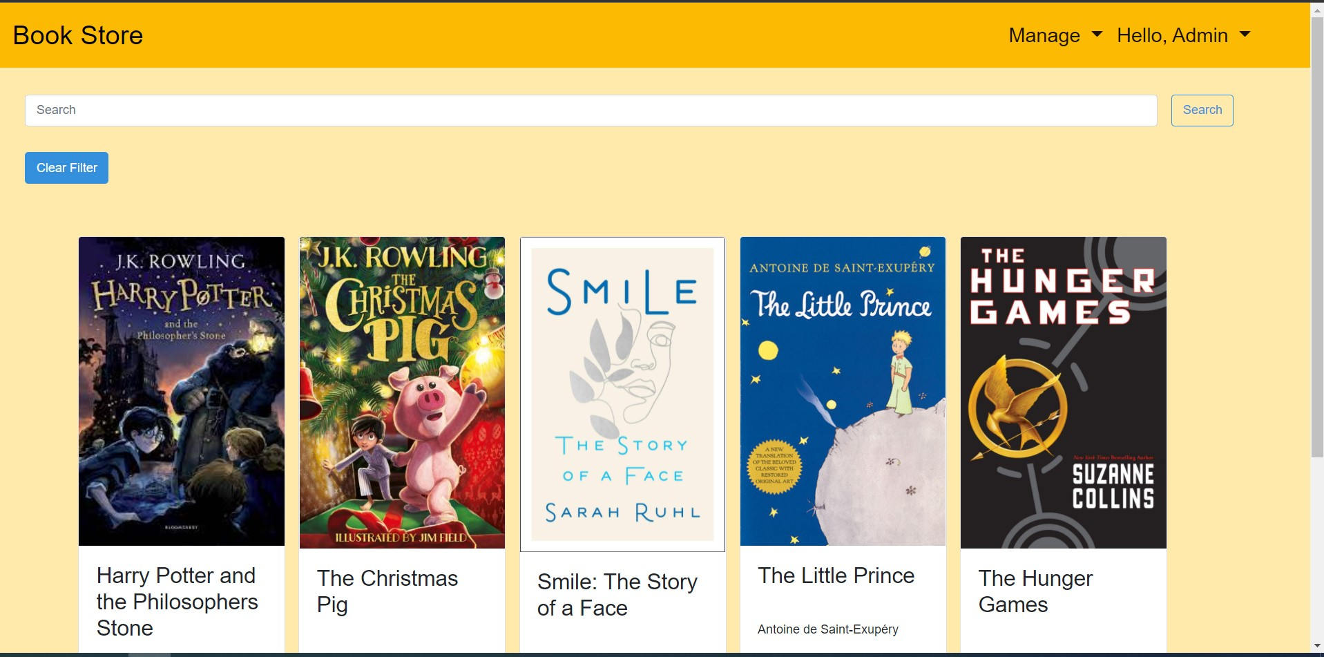

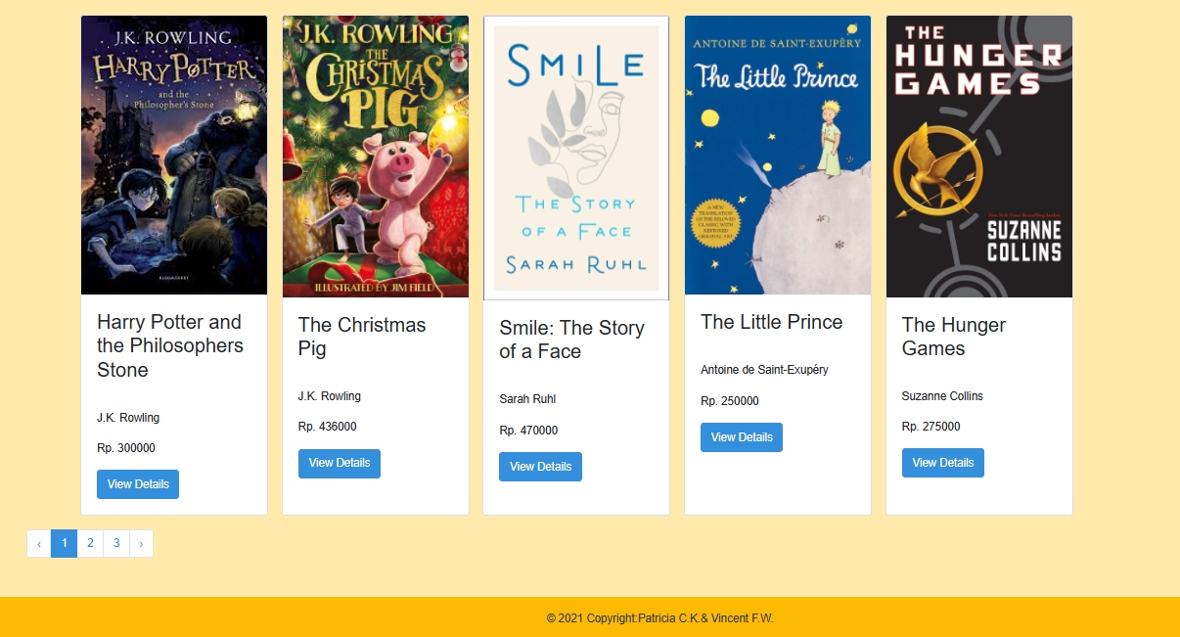

1. Manage book

manage book is only for admin only in here admin can insert new book, delete old books, and view detail(for updating the books detail ).

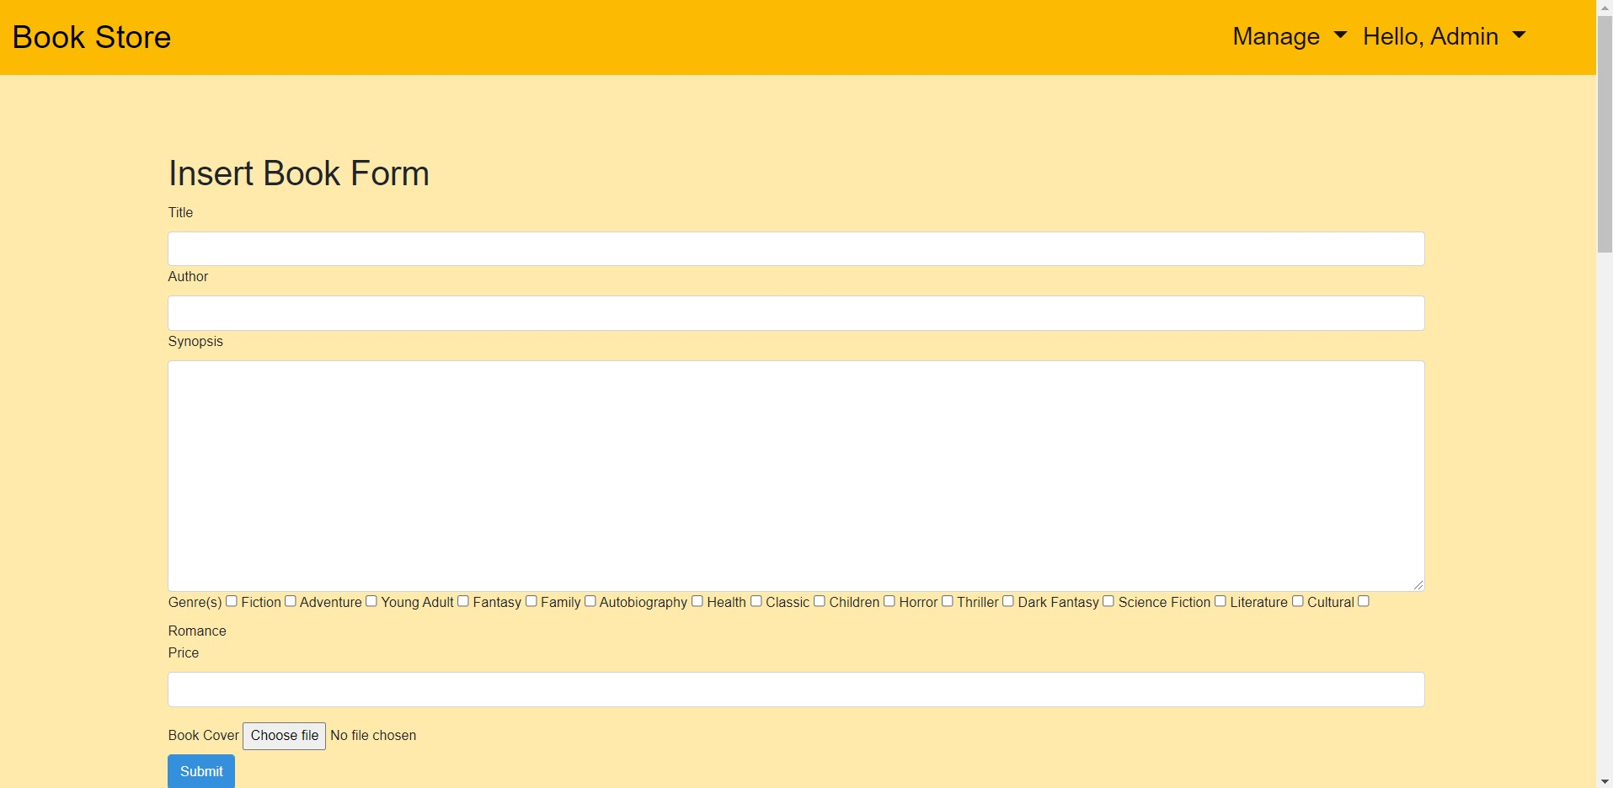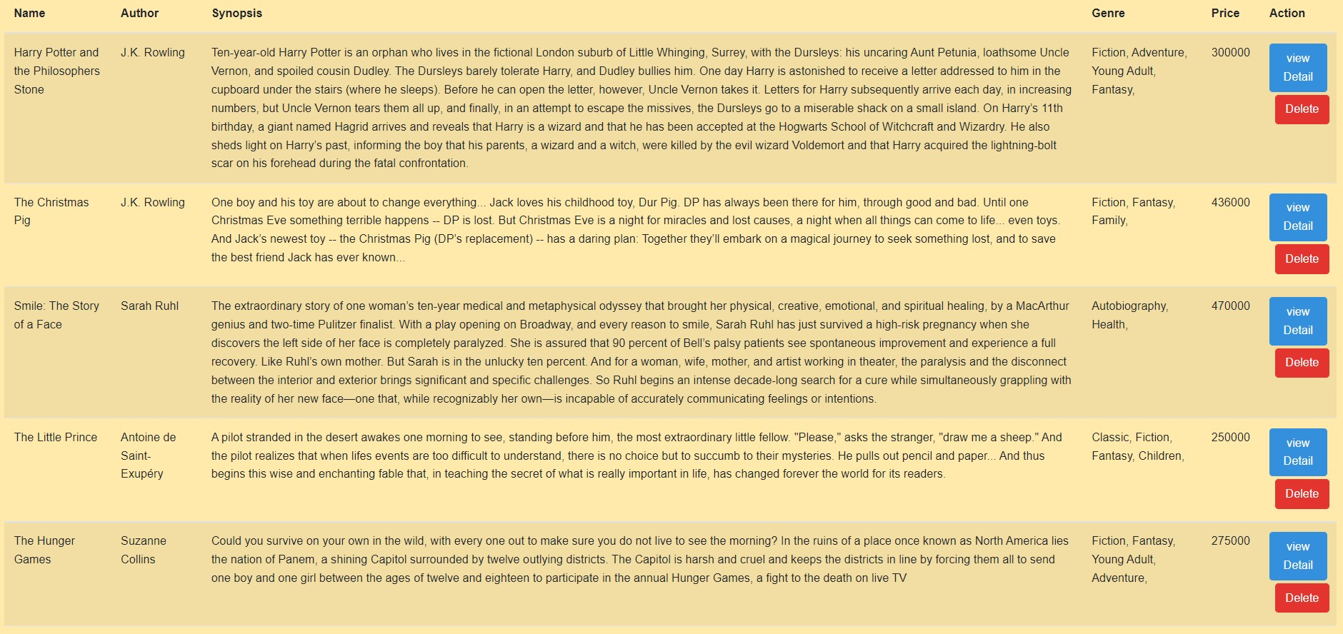

1. Book detail

for book detail will be different for each user role. For admin, admin can see and updating the book detail.

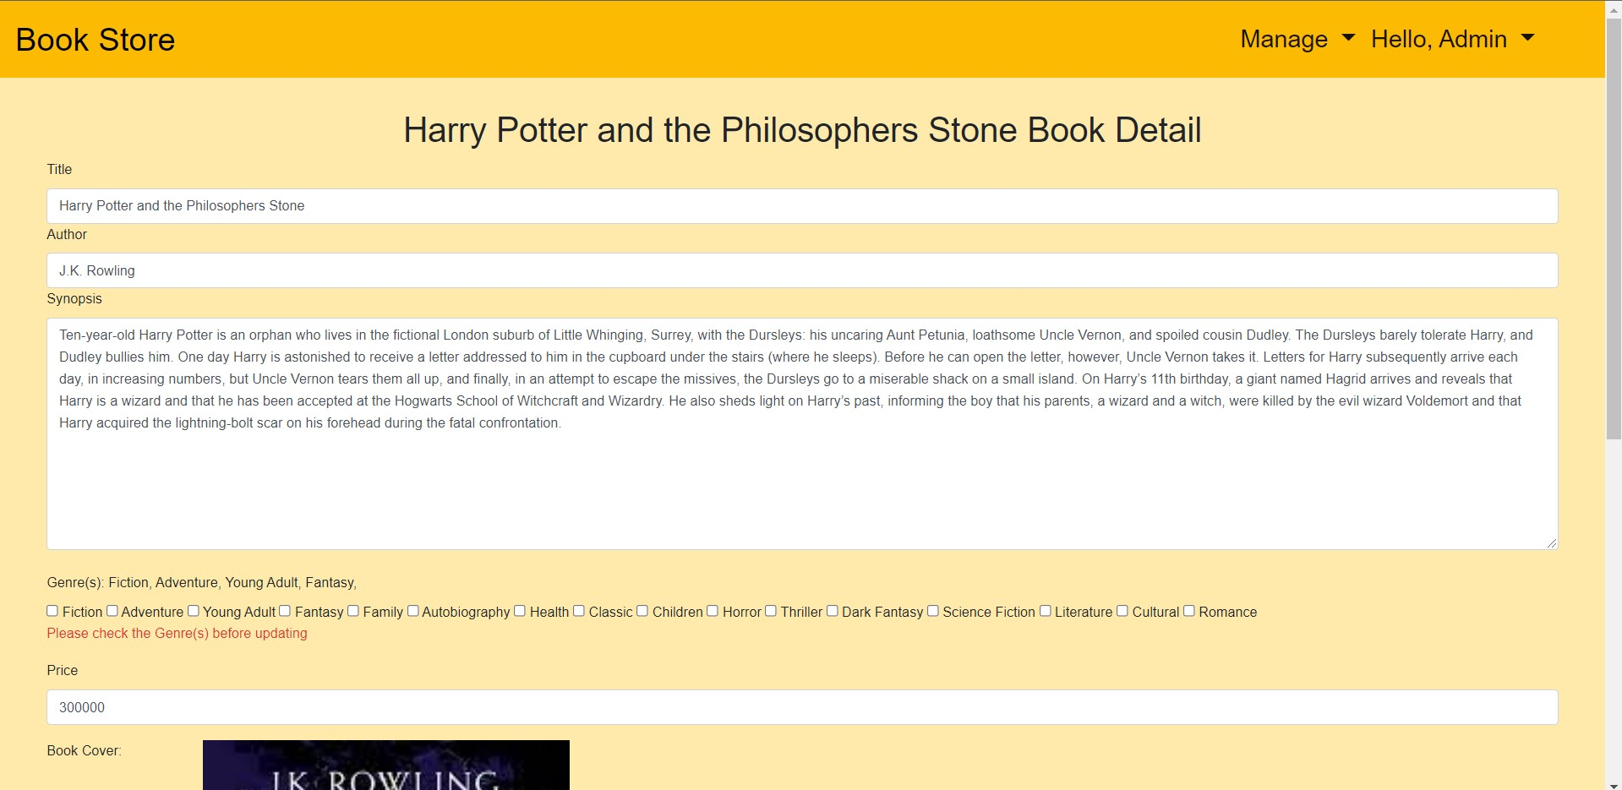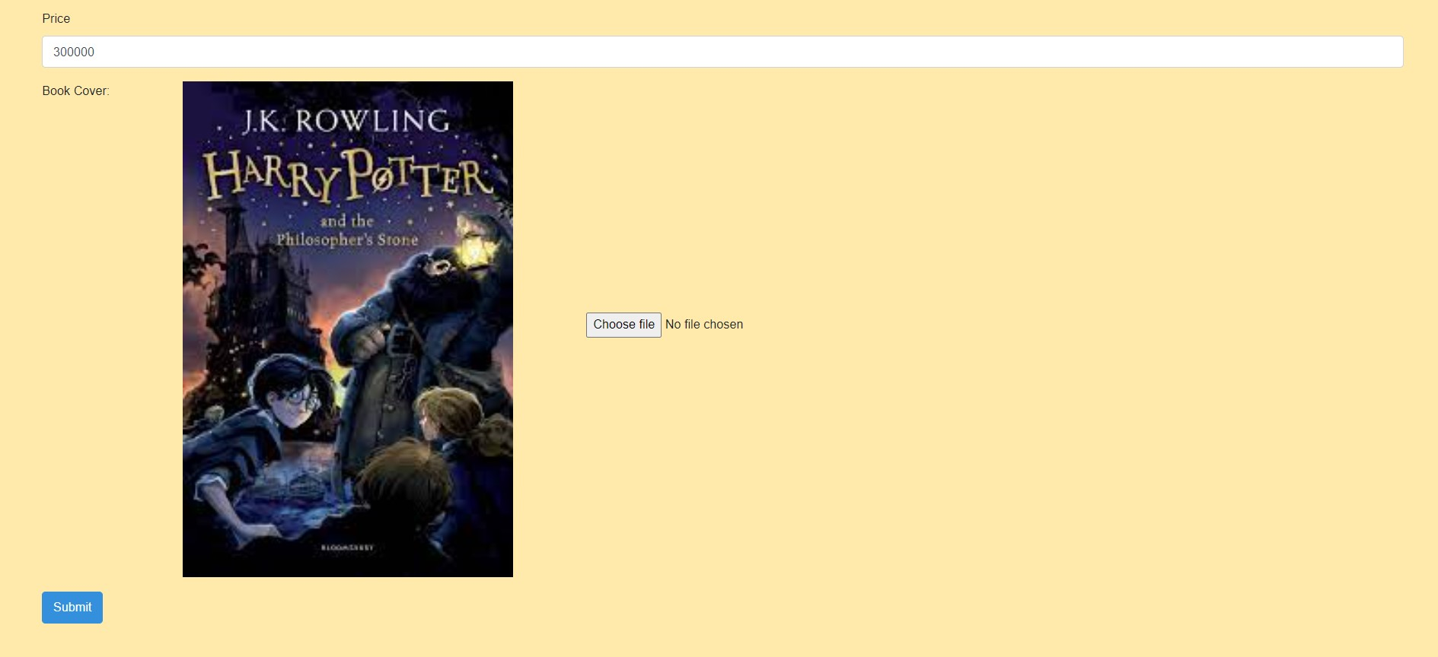

for member, the member can see and read the book detail and can insert the book to cart as much as they want.

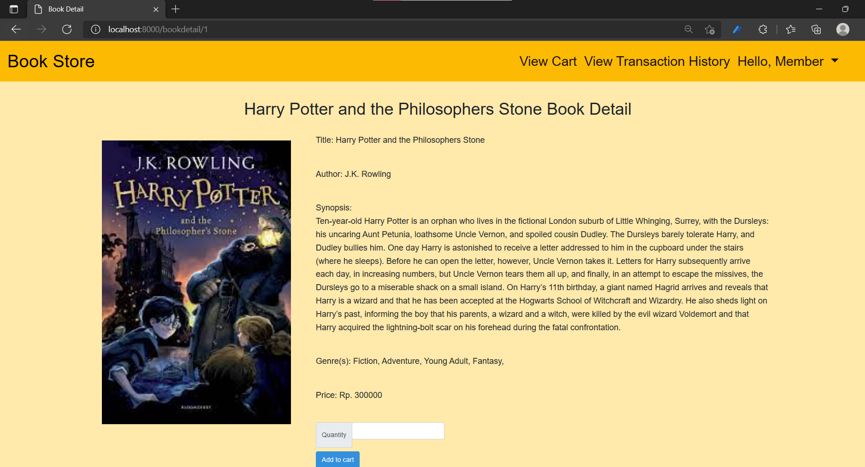

for guest they only can see and read the detail of the book, if they want to buy must be login or register as member.

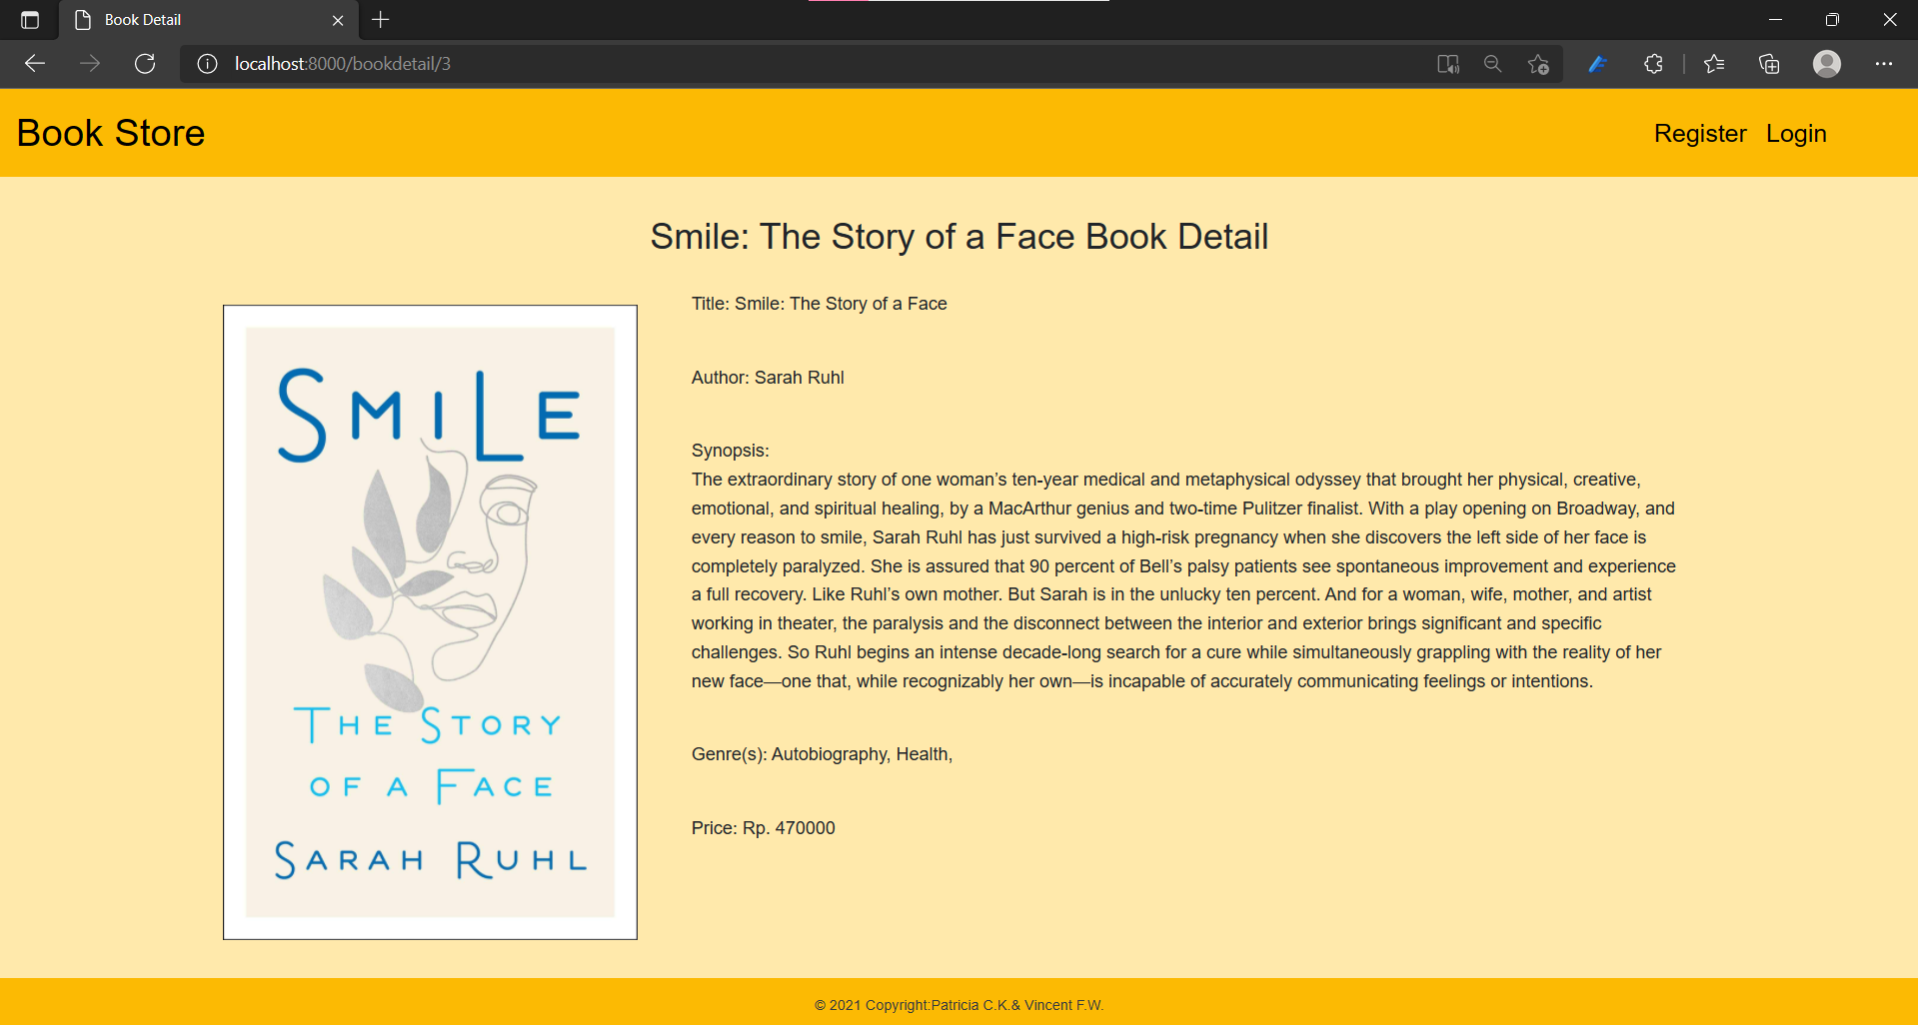

1. Manage genre

manage genre is only for admin, admin can insert new genre, delete genre is the genre not having book on the list. the view detail button will direct admin to genre detail.

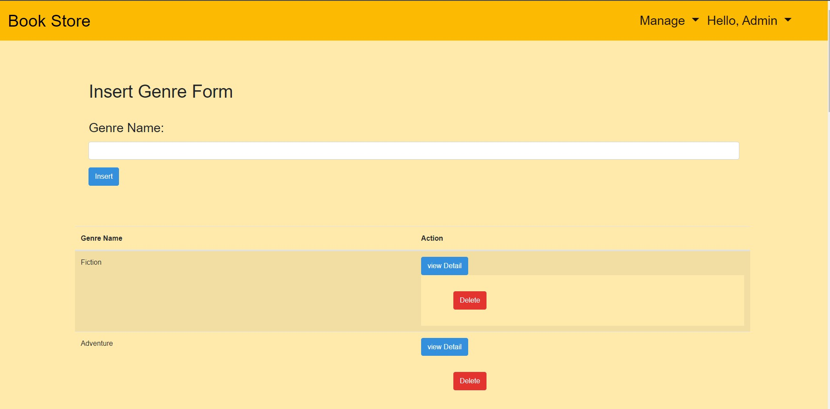

1. Genre detail

in genre detail admin can update the genre name that already chosen in the Manage genre page, admin can also see what books that have the gendre, by clicking the view detail on the title book list admin will be directed to book detail page or admin.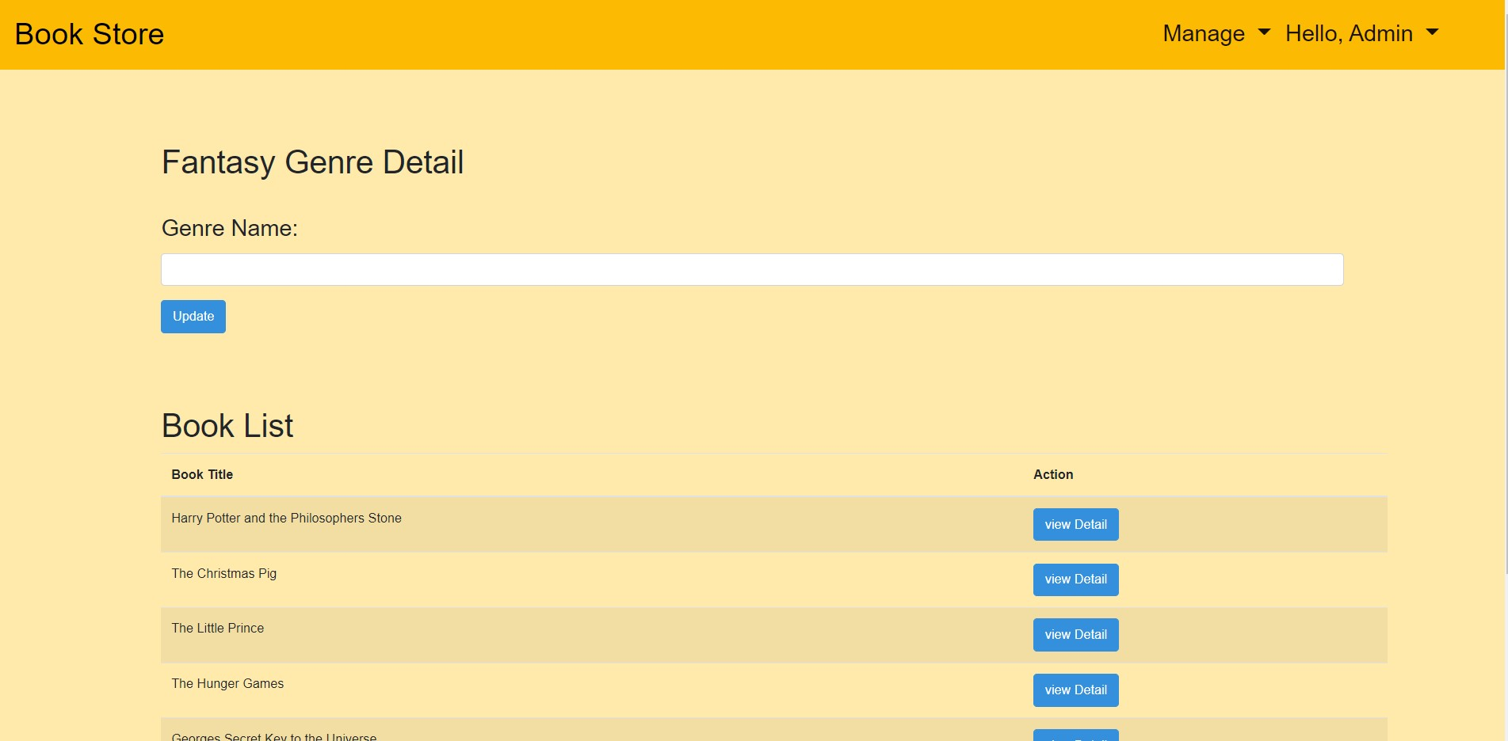

1. Manage user

manage user only for admin, admin can view the user detail (for admin role), for member role admin can delete member, and view user(member detail).

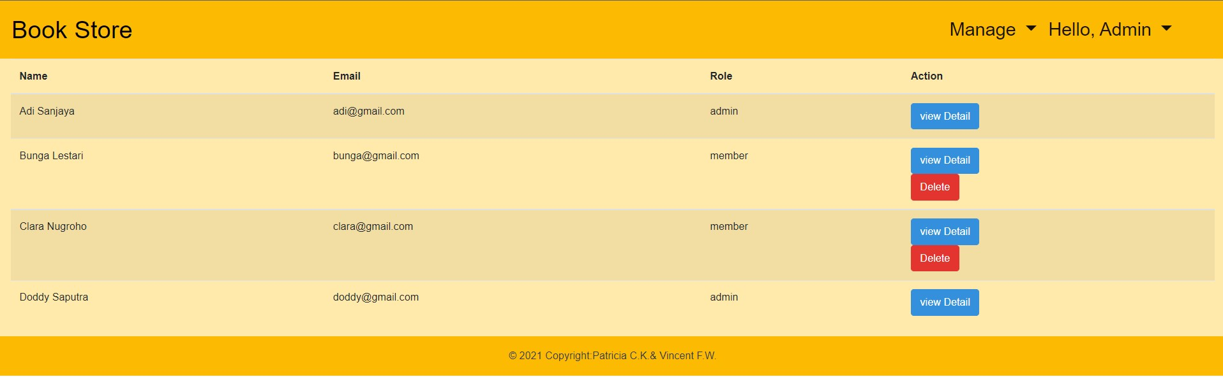

1. User detail

this page also for admin only, admin can change/update the role, name, and email of user (admin and member). 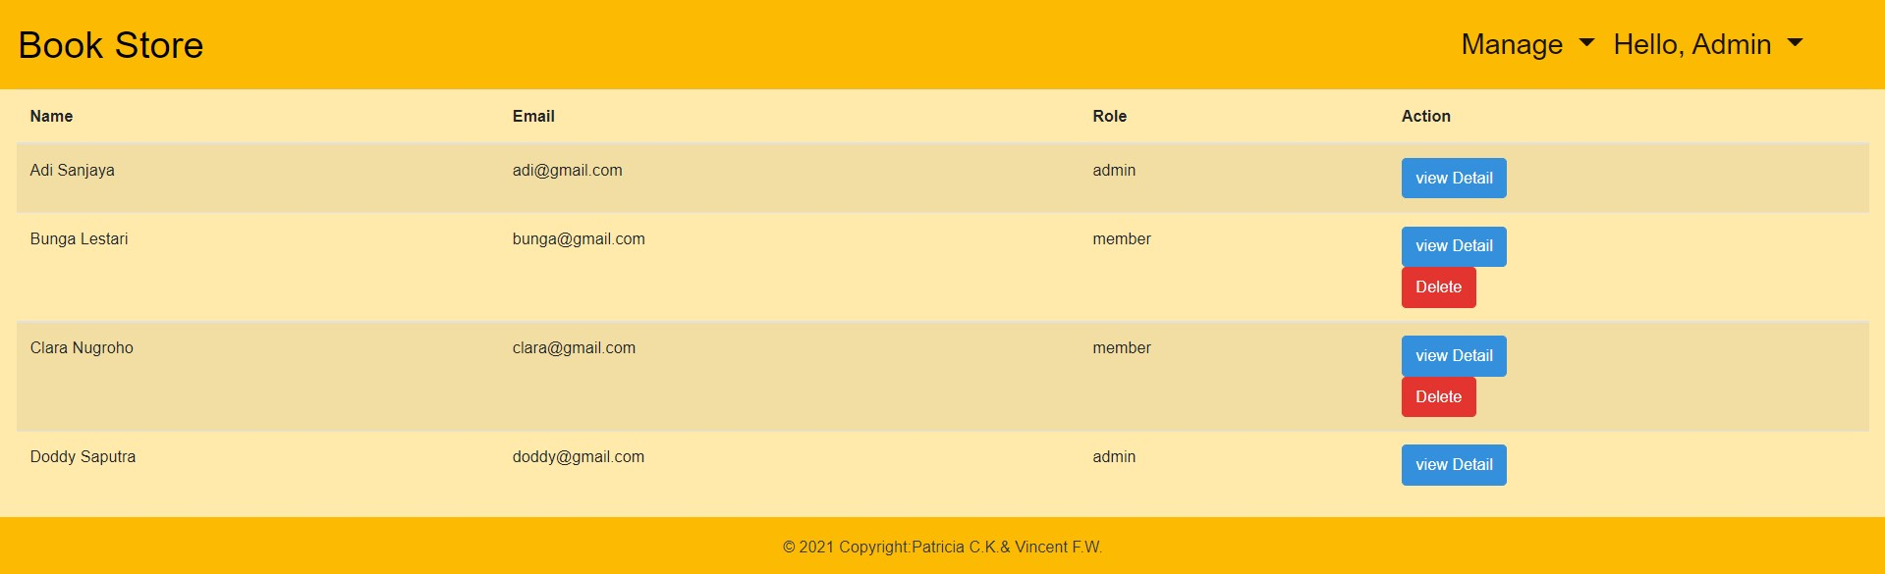

10. View cart

This page is only for members. After adding books to cart (from view book detail for member), members can see the book that they want to buy, the quantity, the sub total, and the grand total. member can also remove item from cart, edit (editing the quantity) by click the edit button, and see the detail by click the view detail of the book

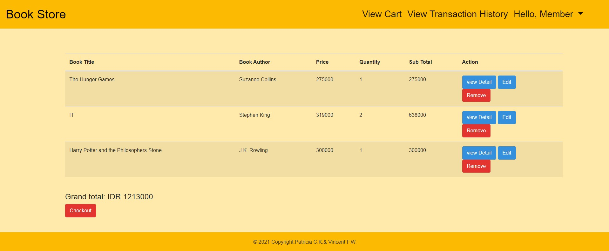

11. Edit cart

This page is also for member only, members will be directed to this page after clicking the edit button on the view cart page. This page is used for editing the quantity of the book on cart (qty must > 0) . Actually on this page members can also see the details of the book.

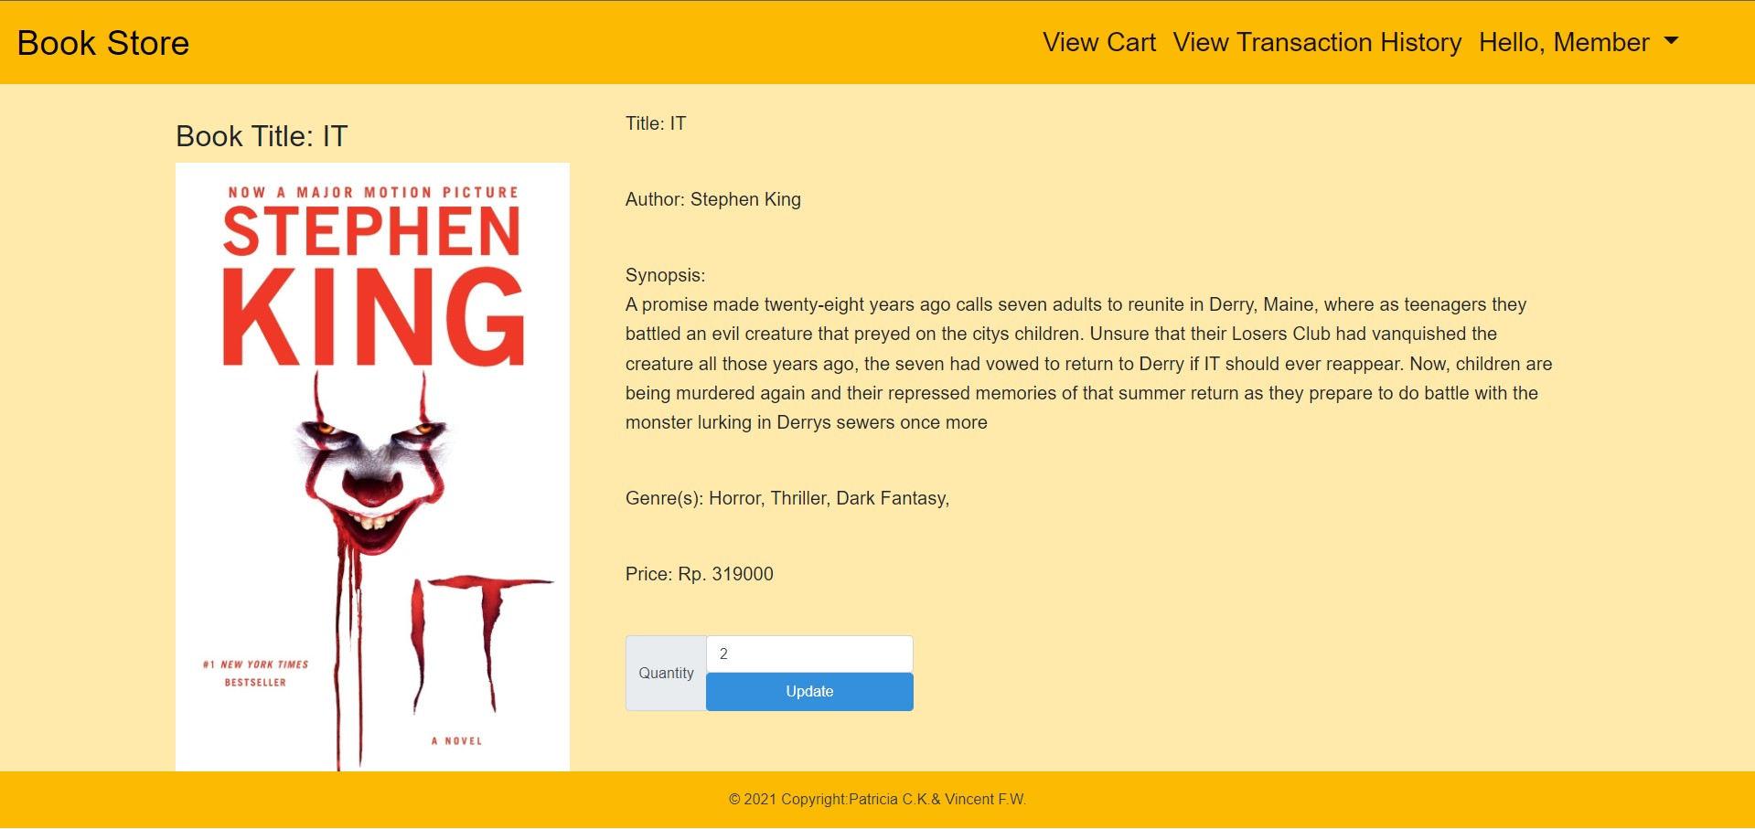

12. View Transaction History

After the user checkout his cart, the transaction is recorded in transaction history

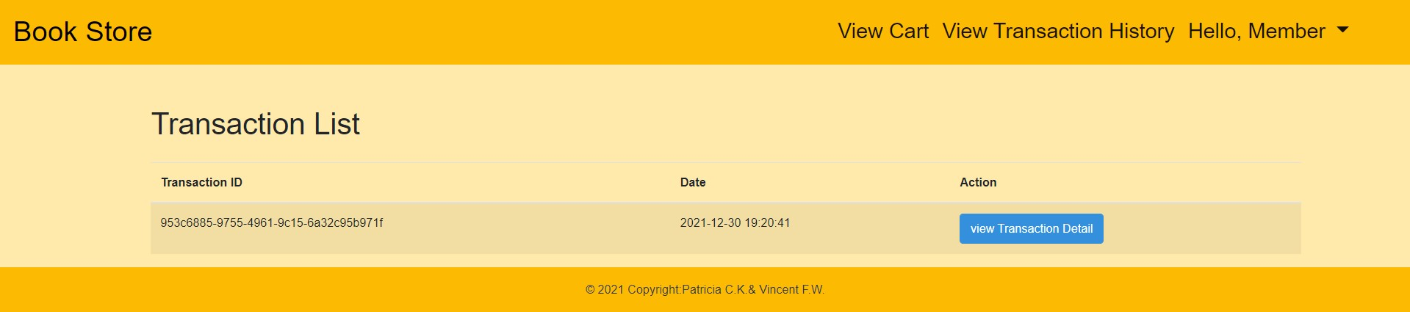

13. View Transaction Detail

After the user clicks view transaction details in their transaction history page, the books that he bought will show.by click the view book detail button user will be directed to the book detail page.

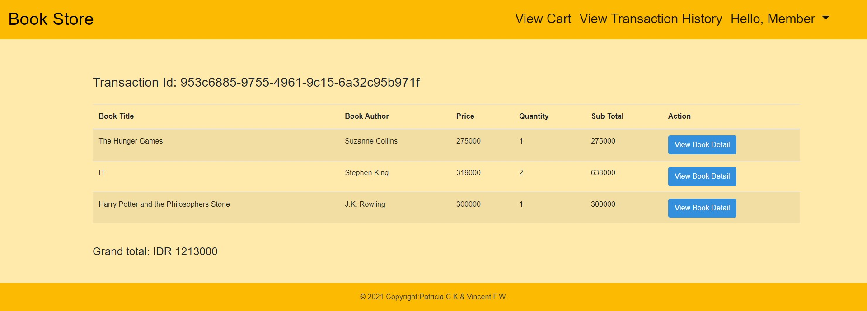

14. Profile page

In this section, users can change their preferred name (for member and admin).by click the change password user will be directed to change password page.

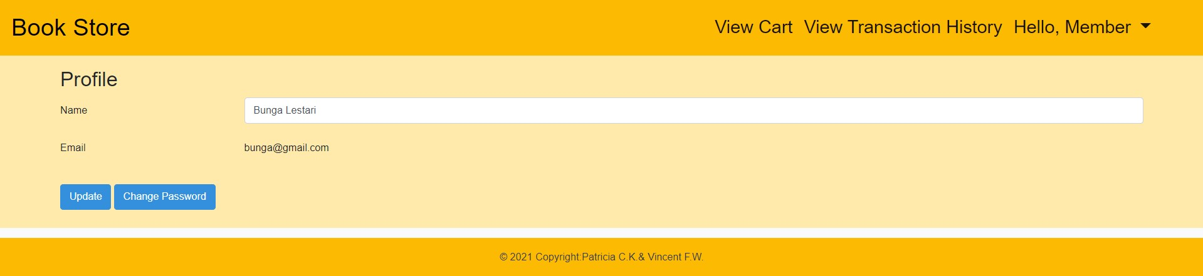

15. Change password

In this section, users who log in can change their password with the new one. (for member and admin)

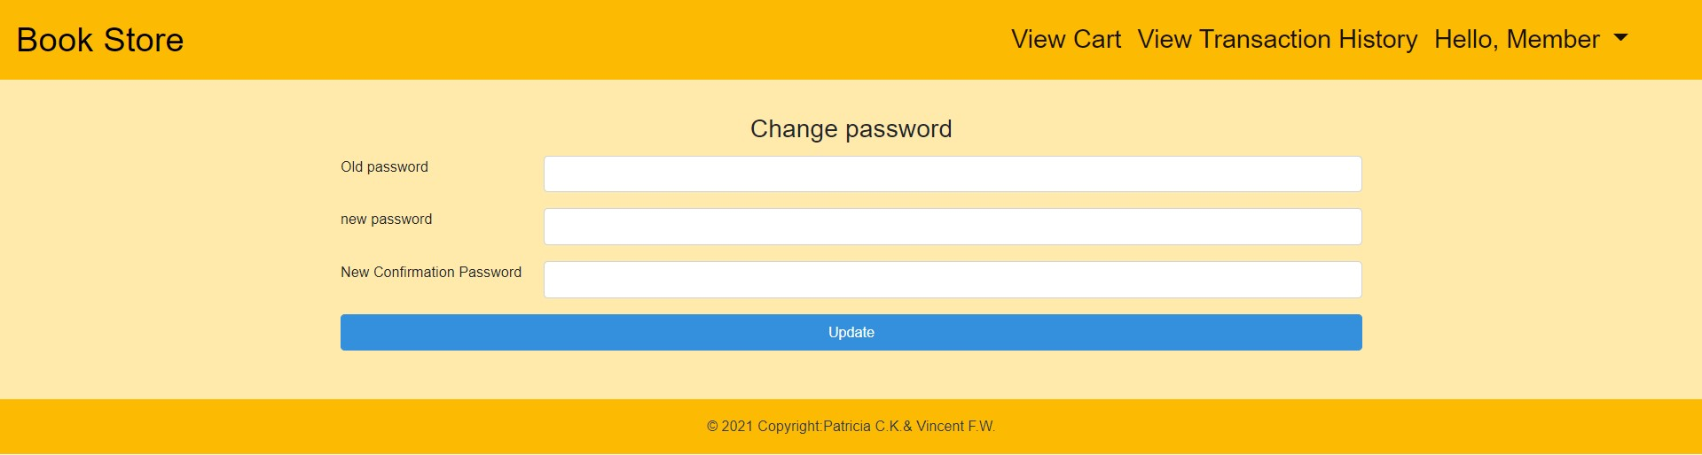

* **Reference**
* · <https://booklounge.co.za/wp-content/uploads/2020/10/hp1.jpg>
* · <https://www.hachetteindia.com/TitleDetails.aspx?titleId=47369>
* ·  [Smile: The Story of a Face: Ruhl, Sarah: 9781982150945: Amazon.com: Books](https://www.amazon.com/Smile-Story-Face-Sarah-Ruhl/dp/1982150947)
* · <https://www.goodreads.com/book/show/157993.The_Little_Prince>
* · <https://id.wikipedia.org/wiki/The_Hunger_Games_(novel)>
* · <https://www.amazon.com/Stephen-King-ebook/dp/B018ER7K5I>
* · <https://www.amazon.com/Georges-Secret-Universe-Stephen-Hawking/dp/1416985840>
* · <https://www.amazon.com/No-Longer-Human-Osamu-Dazai/dp/0811204812>
* · <https://www.goodreads.com/book/show/11297.Norwegian_Wood>
* · <https://www.goodreads.com/book/show/34849669-you-are-the-apple-of-my-eye>
* · <https://www.barnesandnoble.com/w/ready-player-one-ernest-cline/1100055635>
* · <https://cdn.gramedia.com/uploads/items/img508_tsC4kHS__w600_hauto.jpg>
* · <https://www.facebook.com/sadmemeskillme/videos/223255523266687/>
* **Group Member**
* 2301863585 – Patricia Citranegara Kusuma
* 2301885983 – Vincent Fanditama Wijaya